B00XXXXX

EXAMPLE SUBMISSION
YOU CAN USE THIS DOCUMENT AS A TEMPLATE

University of the West of Scotland
Digital Project
Digital Project Individual Report
November 2022

Contents
1. Introduction (this is an example of what this section could include) 3
2. Marketing Plan (worth 5% of your mark) 3
3. SOCIAL MEDIA CONTENT CALENDAR 4
4. Discussion of SEO and Keywords techniques used 5
5. Data Analysis 5
6. Reflection 6
7. References 7
8. Academic Integrity Statement 7

Introduction (this is an example of what this section could include)
The following report will detail the creation of a personal blog around a chosen subject by first showing the marketing plan which was created to help establish the general plan for the blog. Also, a social media content calendar will be included which helped track promotion of the blog across social channels. The report then continues on with an analysis of the keywords and SEO techniques that were employed and discussion of analytics gathered about the blog through google analytics and social media analytics. Finally, the report concludes with a reflection of the entire process of the blog creation. The purpose of my blog was to highlight the fairy-tale stories within football, to take a look into some of the most historic underdog victories within the world’s most popular sport.

LINK TO PUBLISHED BLOG
The link to my blog is: (insert the correct link to your blog here)

MARKETING PLAN

Complete the marketing plan template here as detailed as possible. Include references where you can. This is worth 5% of your mark.

Marketing Plan | Ideas for completion
The title of my blog is | (Include the URL) – why have you chosen this title?
My inspiration for the blog was… | Include some relevant background information here. (e.g. how does it apply to you generally. Include market trends, facts/figures to develop this further
My target audience is… | (try not to just say friends and family)  Eg. If it is on Travel as an Erasmus– include data on people who travel/ do Erasmus/ students – support this with as much relevant market information as possible. Size of market, where they are online and so on. Digital trends and so on. Look at YouGov market information (see Moodle)
My USP (unique selling point) is… | What makes your blog unique? Is it your own personal experience, is it a funny approach? Do you utilize technology in a unique way
My target audience will find it via… | - Social media (Facebook, Twitter, Pinterest) - will you set up unique social media accounts for your blog? Will you promote it on your own personal channels? Would your own network share your content? Is it relevant to them?  - Search engines optimization (we cover this in more detail later in the class so this can be less detailed)  - Syndication (identify relevant bloggers, forums, online groups where you can share the content)  - Hashtags (which ones, how often are they used)  Influencers (who could you involve in your campaign)
My readers will share it because… | Its relevant to them, it tells a story, funny, informative? Is there a ‘call to action’ there? Are you encouraging them to share your content?
How will I test my blog before I publish it (and before I finish this assessment | Examples of market research/market testing: audience research, headline generation, feedback from target market, identification of similar successful content, tools and data sources (basically market testing)
An example of successful content targeting the same target audience is… | Include examples of relevant blogs, websites and so on

- SOCIAL MEDIA CONTENT CALENDAR
(worth 5% of your individual mark)
- Students should complete this as fully as possible and then copy and paste it into your final individual report.
- Remember that students should create, post and promote 4 separate blog posts across your own social media channels. You should promote each blog post as often as possible to increase the number of readers (and therefore views/analytics) on your blog.
- You can create new social media channels to promote your blog too if you like
- You should complete this social media content calendar as fully as possible.

This is an example of a social media content calendar – you can adapt this to suit. I have put in 3 example posts here.
Blog post and title | Day of posting | Time of posting | Platform(s) e.g. Twitter, Facebook, Instagram, whatsapp etc | Comments/feedback from your readers (e.g. number of likes, shares, etc) | Reflection on your post?
Blog post 1 Welcome to my blog | Friday 14 October | 2.30pm | Own facebook page | 3 likes, 2 shares  1 comment “loved this blog” | This post worked well.
Blog post 1 Welcome to my blog | Friday 14 October | 2.36 | Instagram stories | No views | Instagram did not work well today, will try a different day.
Blogpost 2  Travelling to Europe | Friday 21 October | 7.00pm | Instagram stories | 10 views, 2 likes | Instagram worked better in the evening

- DISCUSSION OF SEO AND KEYWORDS TECHNIQUES USED

supported by relevant references and evidence (see Workshop and lecture on SEO) (400 words)
- include a definition of SEO
- Screenshots of how you applied the techniques in your blog (internal/external links, labels, headings) and discussion
- Evidence of using Keyword planner tools etc would really help here (example from Google Ads given below)
- worth 15% of your overall mark

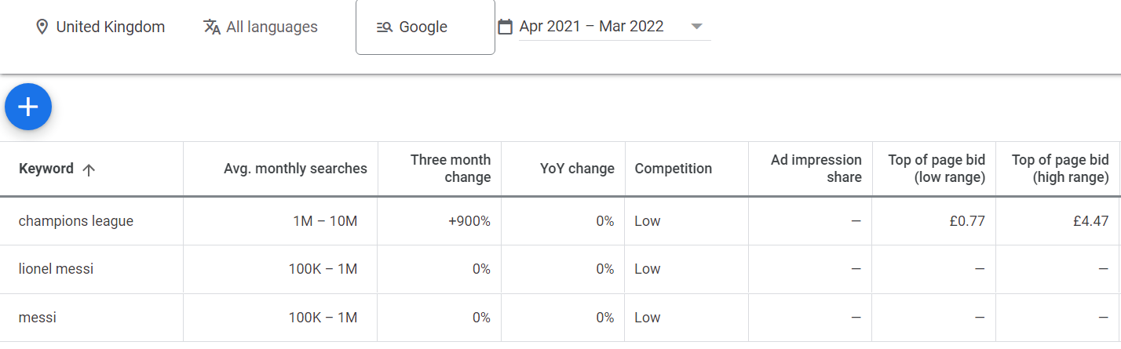
Example Google Ad keyword planner (you should include examples like this with the keywords you have chosen

DATA ANALYSIS
Include some definitions around analytics and then provide some insight into any data you have around your blog, for example screenshots and discussion around any stats from Blogger, and any social media platforms you have used to promote your blog. Try to tell a story around your data. You can use Google Analytics if you wish, however you will need to complete some training to fully understand how this works.
Worth 20 marks. Use screenshots from your analytics to tell the story of your data.
.

REFLECTION
Write a short reflection on the project as a whole, Follow and reference Gibb’s reflective cycle below and discuss each stage of it: descriptions, feelings, evaluation, analysis, conclusion, action plan in relation to your own experience.
Worth 10 marks – be as detailed as possible and be honest

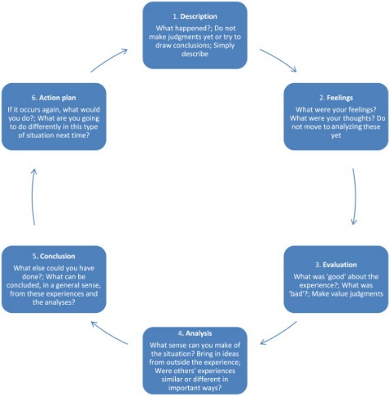

REFERENCES (Harvard style)

ACADEMIC INTEGRITY STATEMENT

Declaration
I hereby declare that:
  - I have read and understood Regulations 3.49—3.55 of Chapter 3 of the Regulatory Framework of the University of the West of Scotland regarding cheating and plagiarism;
  - This assessment is the result of my own work, except for those parts that are
explicitly referenced, and contribution of others is clearly indicated;
  - No material presented in this assessment has been written, wholly or in parts, by any other person(s);
  - This assessment has not been submitted — partially or in full — in support of the completion of assessment(s) on any other module, regardless of previously or the current academic year (self-plagiarism).
Name |  | Date:

